**Electronic Structure Report: Determination of Reaction Mechanism**

Lauren Ruiz

Group Members: Marlene Jacobo, Patsy Griffin, and Deanna Patti

November 13th, 2019

**Abstract**

The goal of this experiment was to determine the internal energy, enthalpy, free energy and entropy of the overall reaction by calculating these values for each step of the mechanism provided. This data was then used to determine which mechanism was more likely to occur and what factors were pushing each reaction forward. GaussView was the program used to obtain the thermodynamic data for each step of the mechanism. The calculated values were found to be 63.440 kcal/mol for the change in enthalpy and 35.503 cal/mol-Kelvin for the change of entropy for each of the overall reactions. It was concluded that the reaction was entropically driven due to the fact that the change in entropy was more positive leading the Gibbs free energy to be more negative which allows for a more spontaneous reaction.

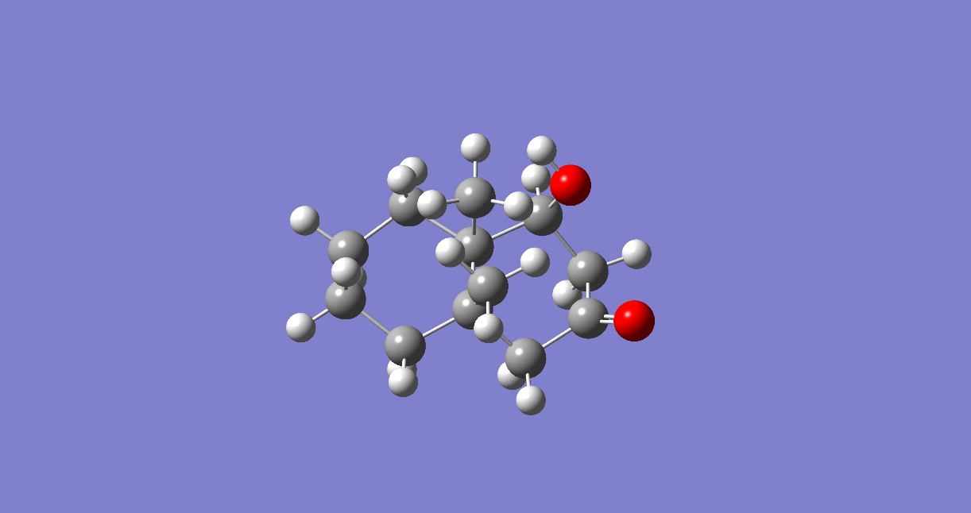

**Introduction**

For the overall reaction, two mechanisms were proposed to show the dehydration of the molecule. Both mechanisms were proposed as possible ways for the reaction to happen. With the use of Gaussian 16, thermodynamic properties were calculated. Below is the overall reaction schematic that was the basis for the mechanisms:

**Overall Rxn**



**Molecule 2**

**Molecule 1**

***Figure 1.*** *Overall Dehydration Reaction*

It should be noted that the reaction is a dehydration reaction. This is due to the loss of the alcohol (OH) due to protonation of the oxygen which allows the alcohol to become a good leaving group, water (H2O). This allows for the double bond between the C-C bond to form as seen in the products side of the schematic. The mechanisms proposed in this experiment are both elimination reactions, specifically an E1 and E2 reaction. The first mechanism proposed was an E1 reaction. This can be seen below:

**Step A_1**



**Step D**

**Step B**

**Molecule 3**

**Molecule 4**

**Molecule 2**

**Molecule 1**

**Step C**

***Figure 2.*** *Mechanism 1: E1 Reaction*

A unimolecular elimination (E1) results from a reaction where the HX substituent gets removed. This then allows for the formation of a double bond. More specifically, E1 reactions involve the deprotonation of a hydrogen on a carbon that is either in the alpha or beta position to a carbocation that then results to an alkene product1. The general mechanism of an E1 reaction can be seen below:

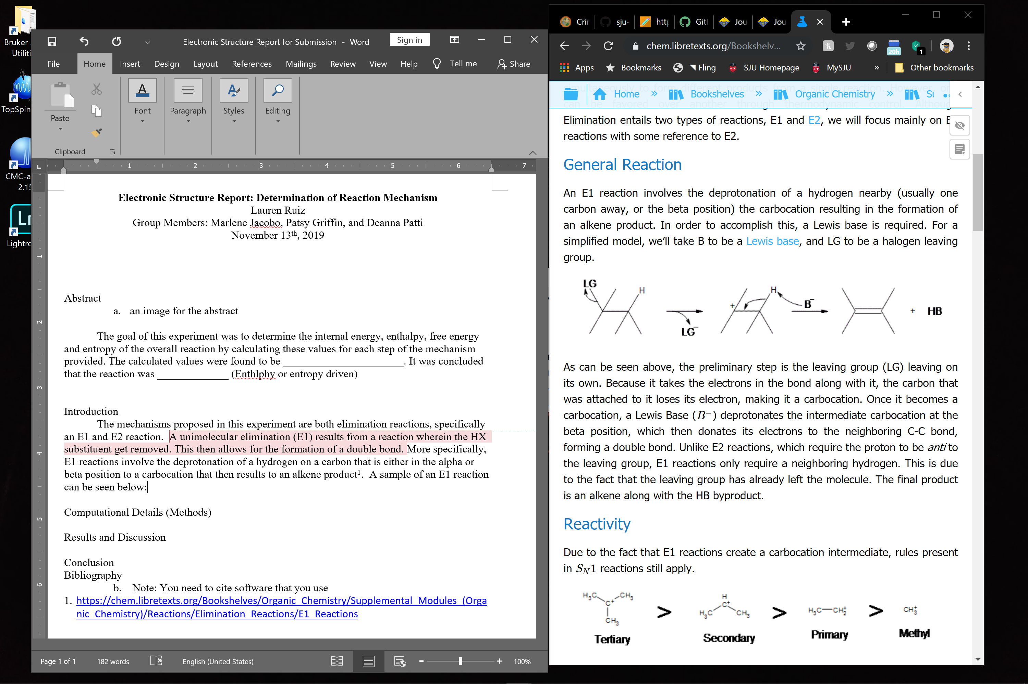

***Figure 3.*** *General Reaction Mechanism for an E1 Reaction1*

In the figure above, B represents a Lewis Bases and LG represents a halogen that is the leaving group. In this mechanism, the leaving group leaves on its own and takes electrons with it. This then leads the carbon it was attached on to form a carbocation. The Lewis Base (B-) then deprotonates the carbocation at the beta position which allows for electrons to be donated to the C-C bond to form an alkene1. Using this simple schematic we can relate this E1 mechanism with the proposed E1 mechanism of the overall reaction.

The second mechanism proposed was an E2 reaction. This can be seen below:

**Step A_2**



**Step F**

**Step E**

**Molecule 1**

**Molecule 2**

**Molecule 3**

***Figure 4.*** *Mechanism 2: E2 Reaction*

E2 reactions are usually seen with secondary and tertiary alkyl halides. It will usually only undergo an E2 reaction with a primary halide when there is a hindered base involved2. Below is an example of an E2 reaction mechanism:

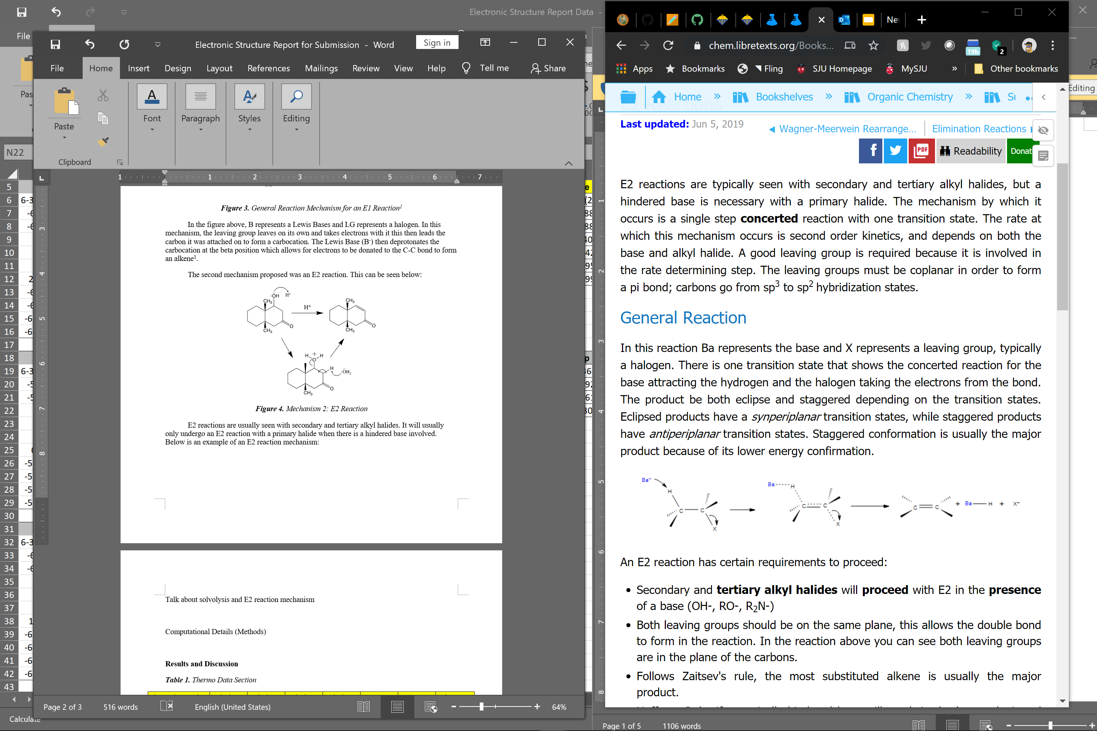

***Figure 5.*** *General Reaction Mechanism for an E2 Reaction2*

Where Ba represents the base and the X represents the leaving group which is usually a halogen. However, an E2 reaction is unlikely due to the presence of a secondary alcohol. Secondary alcohols tend to dehydrate with an E1 mechanism. For it to be an E2 mechanism a strong base is needed.

**Computational Details (Methods)**

For this experiment, GaussView was used to calculate the thermodynamic values for each step of the mechanism. GaussView is a “full-featured graphical user interface for Gaussian 983.” It is a software that allows the modelling of molecules and allows for the calculation of various thermodynamic properties with the use of basis sets3. It is good to note that the Hartree-Fock theory is a simple approximate theory for solving the Hamiltonian equation. The basis of this approximation is the wavefunction that is determined by using the Slater determinant of N spin-orbitals4. On the other hand, Density Functional Theory (DFT), is a method for “*ab inito* calculations of the structure of atoms, molecules, crystals, surfaces and their interactions5.” It improves upon the Hartree-Fock method by including an “approximate treatment of correlated motions of elections6.”

For our calculations the following basis sets were used to build up the calculations in order: (1) Hartree-Fock 321G optimization, (2) DFT 321G Energy, (3) DFT 6-31G Energy, (4) DFT 6-311G Energy, (5) DFT 6-311G(2d) Energy, (6) DFT 6-311G(2d,2p) Energy, and lastly (7) DFT 6-311G(2d,2p) Opt/Freq.

The structures of the molecules were first optimized to allow the model to be in its most stable state. The energies were then calculated starting from a smaller basis set to allow the data to build up when doing the more complicated basis sets allowing for better calculations. The thermodynamic data was only given after running the last step, Opt/Freq. This data was then compiled to further analyze the proposed mechanisms.

**Results and Discussion**

***Table 1.*** *Thermo Data Section*

|  |  |  |  |  |  |  |  |
| --- | --- | --- | --- | --- | --- | --- | --- |
| **Thermo Tab Data Section** | **Molecule 1** | **Molecule 2** | **Molecule 3** | **Molecule 4** | **H3O+** | **H2O** | **Units** |
| **Basis Set** | 6-311G(2d,2p) | 6-311G(2d,2p) | 6-311G(2d,2p) | 6-311G(2d,2p) | 6-311G(2d,2p) | 6-311G(2d,2p) | **-** |
| **E(RB3LYP)** | -619.96079 | -543.39525 | -620.36236 | -543.8859 | -76.856691 | -76.458416 | **Hartree** |
| **Electronic Energy (EE)** | -619.96079 | -543.39525 | -620.36236 | -543.8859 | -76.856691 | -76.458416 | **Hartree** |
| **Heat Capacity (Cv)** | 56.291 | 50.945 | 57.657 | 52.409 | 6.417 | 6.004 | **cal/mol-Kelvin** |
| **Entropy (S)** | 114.459 | 104.864 | 112.214 | 107.422 | 46.101 | 45.098 | **cal/mol-Kelvin** |
| **E (Thermal)** | 199.21 | 179.697 | 207.769 | 187.954 | 23.813 | 15.137 | **kcal/mol** |
| **Dipole Moment** | 2.6863785 | 6.162329 | 11.416291 | 7.0809983 | 1.7809 | 2.13 | **Debye** |

In **Table 1,** these were the Thermo Data values given by the Gaussian 16 program after building up each basis sets. It can be observed that the bigger molecules (Molecule 1-4) have energy levels that are overall much higher than the hydronium and water molecule. This may be due to the presence of more bonds in the bigger molecules. It can also be noted that the calculations took much longer to run for molecules 1-4 than it did for the hydronium and water molecule.

***Table 2.*** *Calculated Data*

|  |  |  |  |  |  |  |  |  |  |
| --- | --- | --- | --- | --- | --- | --- | --- | --- | --- |
| **Calculation Section** | **Step A_1** | **Step A_2** | **Step B** | **Step C** | **Step D** | **Step E** | **Step F** | **Overall Rxn** | **Units** |
| **Change in Free Energy** | 52.855 | 52.855 | -1.215 | -4.780 | 58.851 | -1.215 | 54.071 | 52.855 | **kcal/mol** |
| **Change in Internal Energy** | 62.848 | 62.848 | -2.184 | 6.645 | 58.387 | -2.184 | 65.032 | 62.848 | **kcal/mol** |
| **Change in Enthalpy** | 63.440 | 63.440 | -2.184 | 7.237 | 58.387 | -2.184 | 65.624 | 63.440 | **kcal/mol** |
| **Change in Entropy** | 35.503 | 35.503 | -3.248 | 40.306 | -1.555 | -3.248 | 38.751 | 35.503 | **cal/mol-Kelvin** |

In **Table 2**, these were the values calculated for the change in free energy, internal energy, enthalpy, and entropy for each molecule. It can be observed that **Step A_1** (overall for mechanism 1) and **Step A_2** (overall for mechanism 2) and the **Overall Rxn** all have the same calculated values. Also, the values in **Step A_1** was simply the sum of **Steps B-D**, while **Step A_2** was the sum of **Steps E-F.** The change in enthalpy and change in entropy was then used to calculate the Gibbs Free Energy for each step of the mechanisms.

Based on this data alone, both mechanisms seem possible since the overall energies of each mechanism end up equal to one another. However, more calculations were done to verify this since looking at the energies alone is not enough to make a good argument or to find anything conclusive. These additional calculations can be seen in **Table 3**.

***Table 3.*** *Determination of the State Function that Drives each Step of the Reaction*

|  |  |  |  |  |
| --- | --- | --- | --- | --- |
| **Calculation Section** | **TΔS** | **ΔH** | **ΔG** | **Driven By:** |
| **Step A_1** | 1.06E+04 | 6.34E-02 | -1.06E+04 | Entropy |
| **Step A_2** | 1.06E+04 | 6.34E-02 | -1.06E+04 | Entropy |
| **Step B** | -9.68E+02 | -2.18E-03 | 9.68E+02 | Enthalpy |
| **Step C** | 1.20E+04 | 7.24E-03 | -1.20E+04 | Entropy |
| **Step D** | -4.64E+02 | 5.84E-02 | 4.64E+02 | Enthalpy |
| **Step E** | -9.68E+02 | -2.18E-03 | 9.68E+02 | Enthalpy |
| **Step F** | 1.16E+04 | 6.56E-02 | -1.16E+04 | Entropy |
| **Overall Rxn** | 1.06E+04 | 6.34E-03 | -1.06E+04 | Entropy |

In **Table 3**, Using the TΔS values, where T was defined as 298.15K, and ΔH values we were able to determine if the systems were spontaneous or not by determining if the ΔG was negative or positive using the Gibbs Free Energy equation7. To determine if the step was driven by entropy or enthalpy, the TΔS values were compared to the ΔH values to see which function is pushing the step towards being spontaneous. If one of these functions is pushing the ΔG to be more negative, we know that this is function driving the reaction for a particular step. It was noticed that Step D is a reaction that is nonspontaneous at all temperatures since TΔS was found to be negative and ΔH was found to be positive, pushing the Gibbs Free Energy to be more positive by both of the state functions, which might say that the E1 mechanism is not likely to happen.

**Conclusion**

Based on the organic chemistry, it can be hypothesized that E2 was an unlikely mechanism since secondary alcohols tend to dehydrate with an E1 mechanism. As stated before, a strong base would be needed for an E2 mechanism to work. However, based on the Thermo Data collected from the calculations, both mechanisms have the same overall change in free energy, internal energy, enthalpy, and entropy which might make it seem that both mechanisms are possible. Which contradicts the first hypothesis that E2 was an unlikely mechanism.

Further analysis was done and each step was analyzed to see what was the condition driving each step of the mechanism, whether it is entropy or enthalpy. This was done by calculating the TΔS values, where T was defined as 298.15K, and ΔH values. Using these values, we analyzed which of the two values pushed the Gibbs Free Energy to be more negative. This value was then determined to be the driving force of the reaction. These deductions can be seen in **Table 3.** Upon further analysis, Step D was found to be a reaction that is nonspontaneous at all temperatures, since it was found to be pushing the Gibbs Free Energy to be more positive by both of the state functions. This then makes E1 to seem like the unlikely mechanism which also contradicts the initial hypothesis. However, Gaussian does not take into account real-world interactions of the water with the molecule since the simulation only runs in a gas phase that acts like water. This may be a reason why this particular step is nonspontaneous. Lastly, it was concluded that the reaction was entropically driven due to the fact that the change in entropy was more positive. This means the reaction is endothermic and the reaction takes place spontaneously.

Some things that should be improved on in the future is building up the calculations. We found that trying to do the more complicated calculations sooner took a significant amount of time longer than when starting with more simpler basis sets and to build up the calculations. In the future more calculations should be done to get a better set of thermodynamic data and to find more conclusive evidence as to which mechanism is likely to occur since the thermodynamic data currently contradicts the initial hypothesis based on our knowledge of organic chemistry. More study should also be done on the theory since currently a lot of the data does not agree with each other but also one must take into account what the Gaussian program is lacking in terms of the environment the reaction is taking place. Our Gaussian calculations are based solely on ideal situations which don’t necessarily happen in the real world.

**Molecules Created in GaussView8**

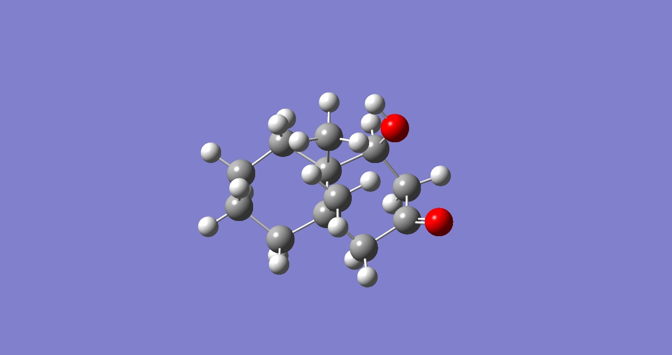

**Figure 6.** Molecule 1

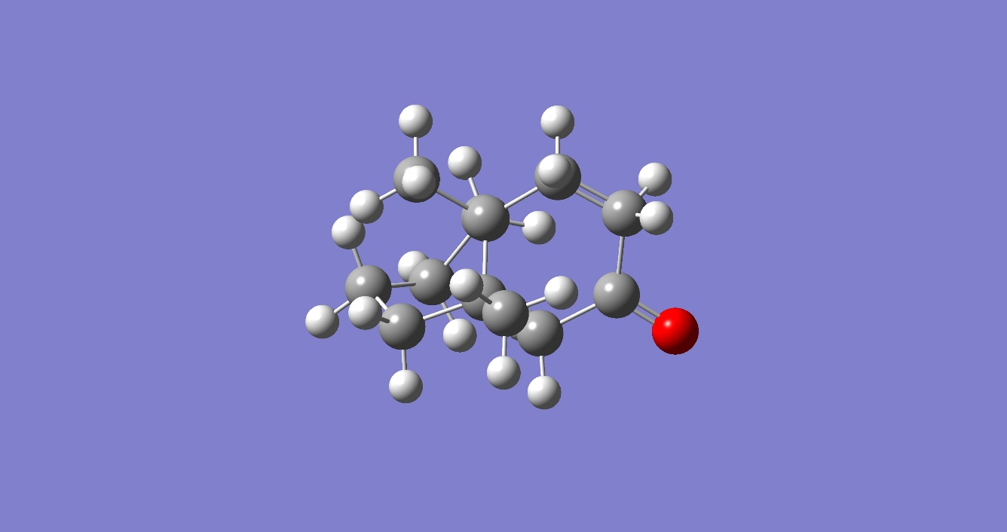

**Figure 7.** Molecule 2

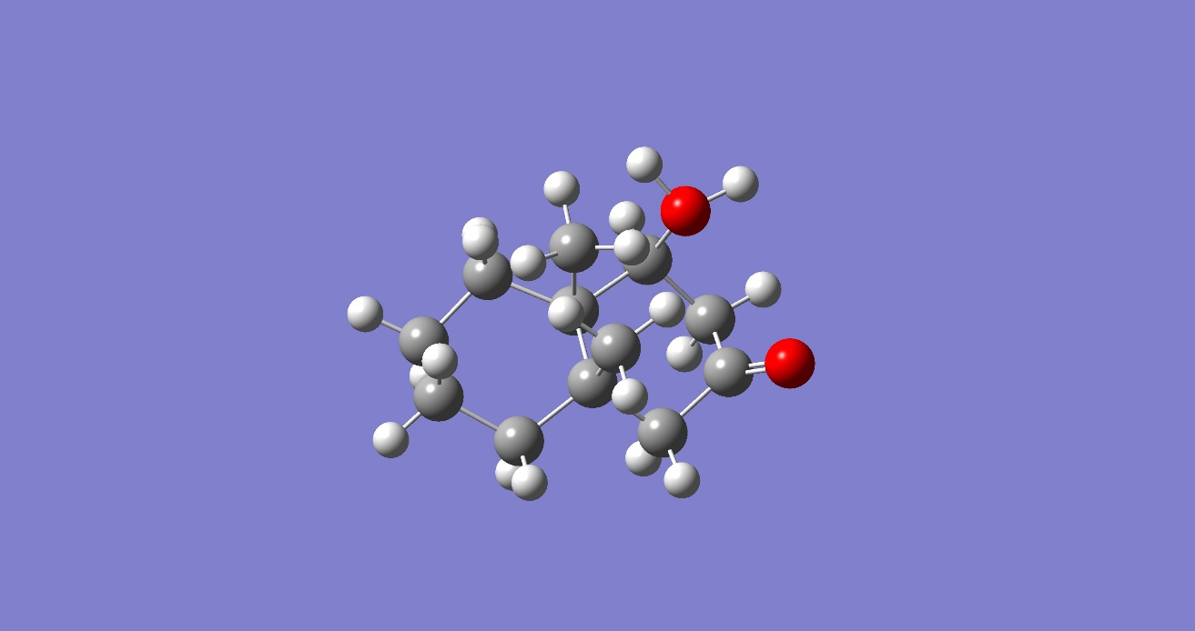

**Figure 8.** Molecule 3

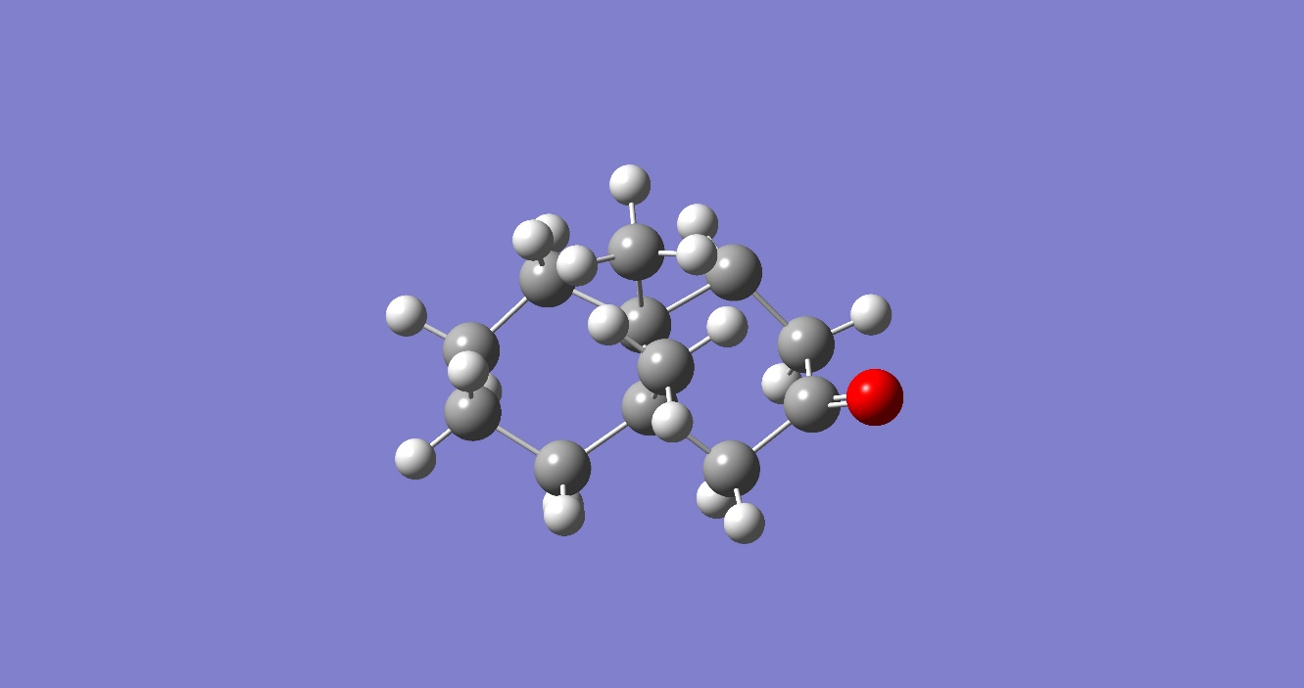

**Figure 9.** Molecule 4

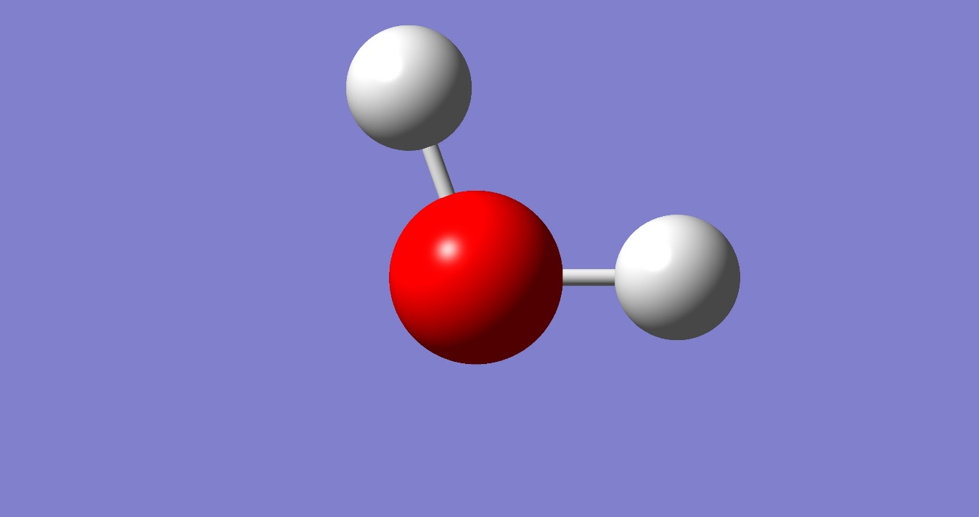

**Figure 10.** WaterMolecule

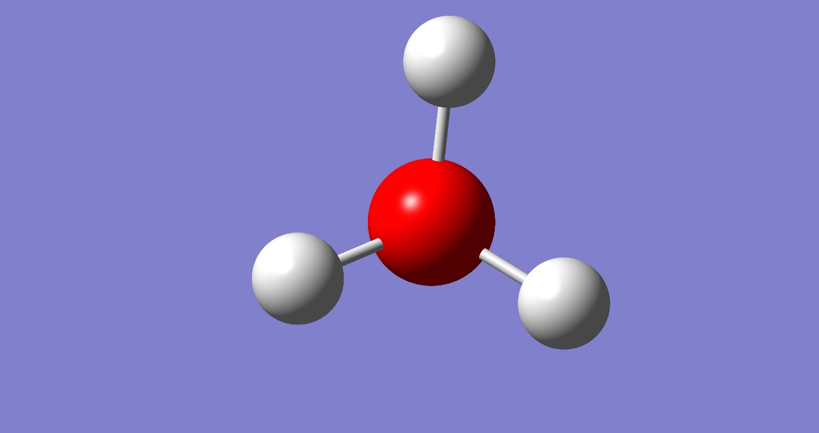

**Figure 11.** HydroniumMolecule

**Bibliography**

* + - 1. Libretexts. E1 Reactions. *https://chem.libretexts.org/Bookshelves/Organic_Chemistry/Supplemental_Modules_(Organic_Chemistry)/Reactions/Elimination_Reactions/E1_Reactions* (accessed Nov 13, 2019).
      2. Libretexts. E2 Reactions. *https://chem.libretexts.org/Bookshelves/Organic_Chemistry/Supplemental_Modules_(Organic_Chemistry)/Reactions/Elimination_Reactions/E2_Reactions* (accessed Nov 13, 2019).
      3. GaussView. *http://www.hoffmanndatentechnik.com/gvbroc.htm* (accessed Nov 13, 2019)
      4. Kent, P. 2.3 Hartree Fock theory. *https://web.ornl.gov/~kentpr/thesis/pkthnode13.html* (accessed Nov 13, 2019).
      5. American Journal of Physics **68**, 69 (2000); [*https://doi.org/10.1119/1.19375*](https://doi.org/10.1119/1.19375)
      6. Sherill, C. D. Introduction to Density Functional Theory. *http://vergil.chemistry.gatech.edu/notes/DFT-intro.pdf* (accessed Nov 13, 2019).
      7. Enduring Understanding 5.E.2: Gibbs Free Energy. *http://www.softschools.com/notes/ap_chemistry/gibbs_free_energy/* (accessed Nov 13, 2019).
      8. Gaussian 16, Revision C.01, Frisch, M. J.; Trucks, G. W.; Schlegel, H. B.; Scuseria, G. E.; Robb, M. A.; Cheeseman, J. R.; Scalmani, G.; Barone, V.; Petersson, G. A.; Nakatsuji, H.; Li, X.; Caricato, M.; Marenich, A. V.; Bloino, J.; Janesko, B. G.; Gomperts, R.; Mennucci, B.; Hratchian, H. P.; Ortiz, J. V.; Izmaylov, A. F.; Sonnenberg, J. L.; Williams-Young, D.; Ding, F.; Lipparini, F.; Egidi, F.; Goings, J.; Peng, B.; Petrone, A.; Henderson, T.; Ranasinghe, D.; Zakrzewski, V. G.; Gao, J.; Rega, N.; Zheng, G.; Liang, W.; Hada, M.; Ehara, M.; Toyota, K.; Fukuda, R.; Hasegawa, J.; Ishida, M.; Nakajima, T.; Honda, Y.; Kitao, O.; Nakai, H.; Vreven, T.; Throssell, K.; Montgomery, J. A., Jr.; Peralta, J. E.; Ogliaro, F.; Bearpark, M. J.; Heyd, J. J.; Brothers, E. N.; Kudin, K. N.; Staroverov, V. N.; Keith, T. A.; Kobayashi, R.; Normand, J.; Raghavachari, K.; Rendell, A. P.; Burant, J. C.; Iyengar, S. S.; Tomasi, J.; Cossi, M.; Millam, J. M.; Klene, M.; Adamo, C.; Cammi, R.; Ochterski, J. W.; Martin, R. L.; Morokuma, K.; Farkas, O.; Foresman, J. B.; Fox, D. J. Gaussian, Inc., Wallingford CT, 2016.